“Homely” Biscuits
Ingredients:

- 1 cup White Long Grain Fancy Rice flour
- ½ cup Soft Red Winter Wheat flour
- ½ cup Illinois Blue Corn flour
- 3 tablespoons clarified butter
- 5 to 6 tablespoons water or add as required
- 2 teaspoon carom seeds
- 2 teaspoon black peppercorns – crushed coarsely
- 2 teaspoon dry fenugreek leaves
- 1 teaspoon cumin seeds
- 1 pinch baking soda
- salt as required
- oil as required, for deep frying

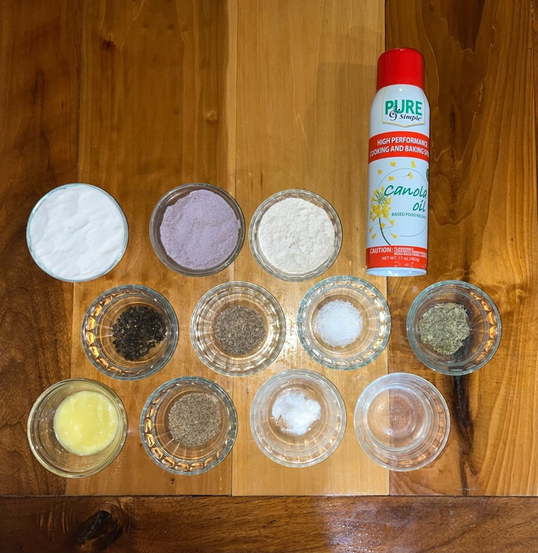

Procedure:
- First heat the clarified butter until hot. Take the heated butter and flours, all the spices, dry fenugreek leaves, salt and baking soda in a mixing bowl.
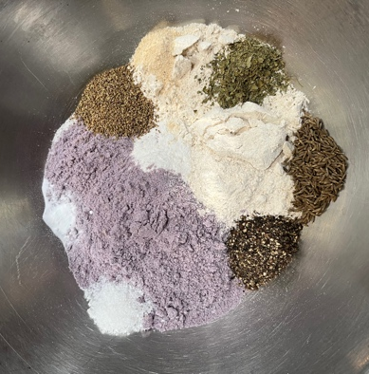
- First mix everything well with a spoon. Then when the mixture is warm or cool enough to handle, mix the fat evenly in the flour with your fingertips.
- The whole mixture should resemble breadcrumbs. The more you do this, the more flaky texture the biscuit will have.
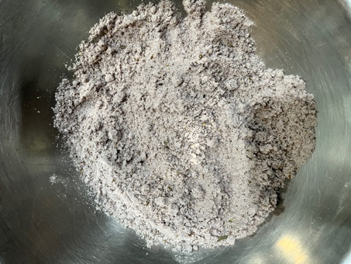
- Add 1 or 2 tablespoons of water at a time and only mix the dough. Don’t knead. But only mix the water in the dough until it comes together.
- When the whole mixture can be easily clumped or gathered together into a ball, cover with a kitchen towel and keep aside to rest for 30 mins.
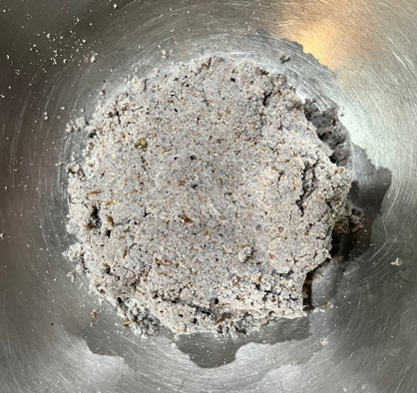
- Heat oil for frying in a frying pan. Pinch small balls from the dough. Simply roll them lightly in your palms to even them.
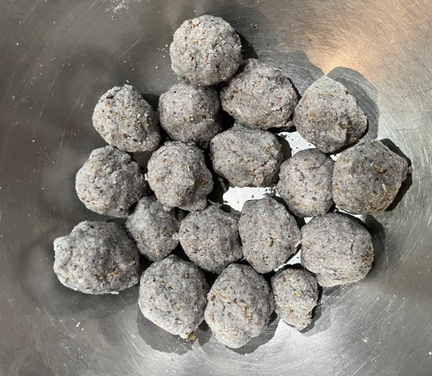
- Keep the balls covered with a kitchen towel so that they do not dry out.
- Flatten each ball with a rolling pin to medium thickness. You will see jagged uneven edges and they are alright.
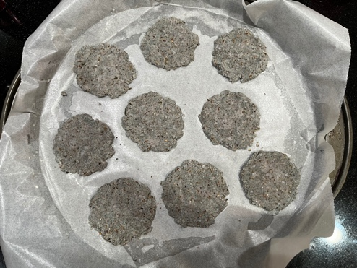
- Check the hotness of oil before frying the mathari.
- Drop a small piece and if comes to the surface gradually, then the oil is ready.
- If it comes to quickly, then the oil is very hot and the mathri will brown from out but remain uncooked from inside and will become soft.
- If it comes slowly, then the oil is cold. Result would be the mathari would absorb a lot of oil and become dense due to over frying.
- Fry them in medium hot oil turning over as needed until crisp and golden.
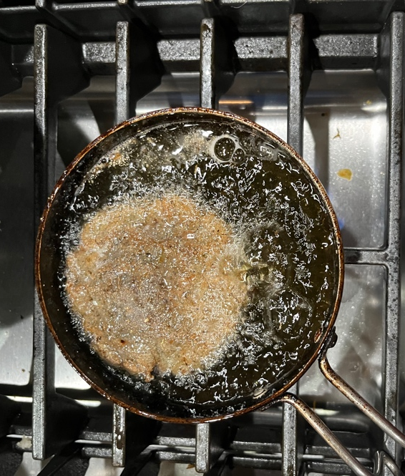
- Regulate the heat between medium-low to medium if required.
- Drain on kitchen paper towels and when cooled store them in an airtight box.
- Fry them in batches this way.

