RECIPE
Hail to the Blue Corn Muffins
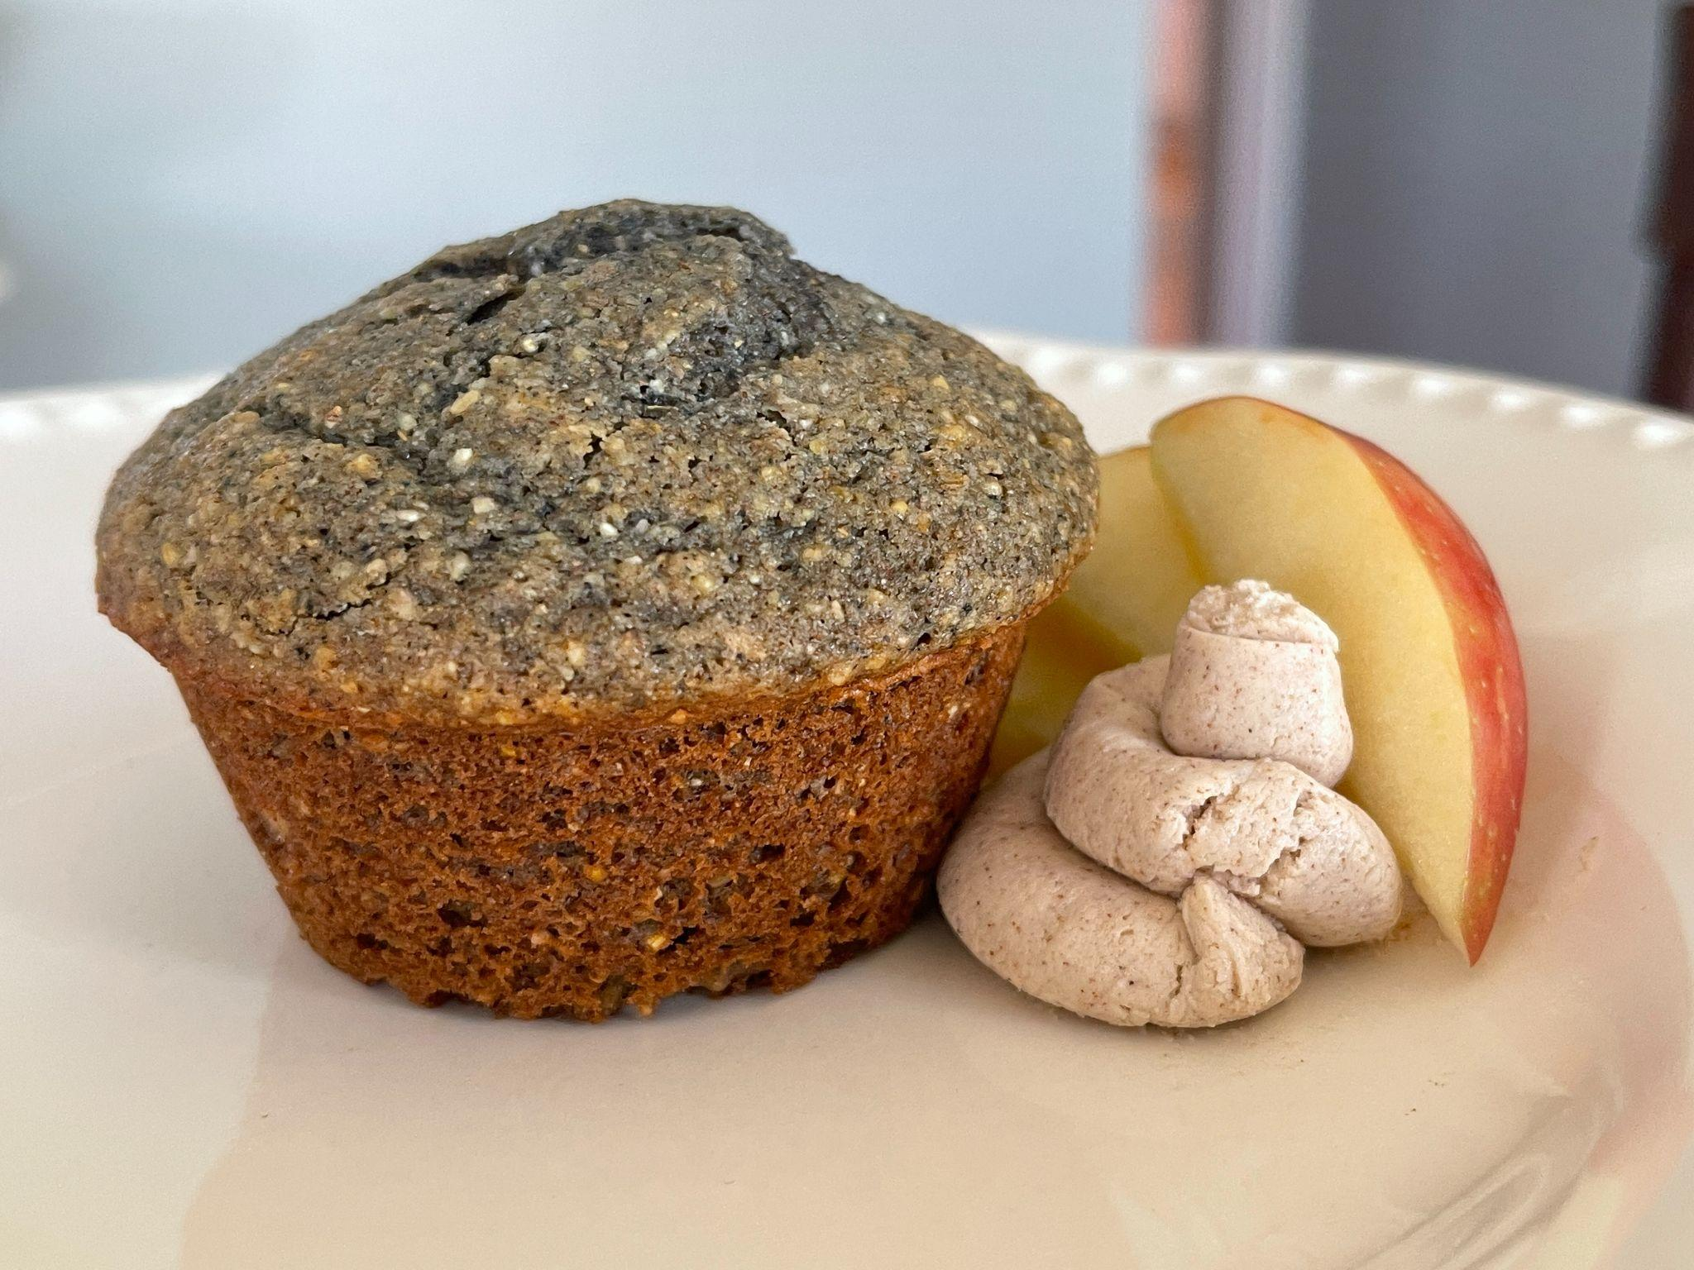
Ready in 40 minutes
Serves 14 people

Ingredients -
Corn Muffins
- 1 cup Illinois Blue Corn
- 1 cup Soft Red Winter Wheat
- 1 cup yellow corn meal
- 1 ½ tsp baking powder
- 1 tsp baking soda
- ¼ tsp table salt
- 1 ½ tsp cinnamon
- 2 eggs
- ⅔ cup raw honey
- 8 tbsp melted butter
- ¾ cup vanilla greek yogurt
- ⅓ cup oat milk
- 2 oz apple nibs ( diced apples coated in cinnamon and sugar )
Goat Cheese Spread
- 4 oz goat cheese, softened
- 1 tsp cinnamon
- 1 tsp honey

Preparation
- Preheat oven to 375℉. Butter 14 sections in a muffin pan.
- Sift together blue corn, soft red winter wheat, baking soda, baking powder, salt and cinnamon. In a large bowl, whisk dry mixture with cornmeal. Set aside.
- Whisk eggs in a medium bowl until well combined. Add in the honey, melted butter, greek yogurt, and oat milk and whisk until well combined.
- Combine the wet ingredients with the dry mixture, mixing gently. Be careful not to overmix! Gently fold in the apple nibs.
- Divide the batter evenly into 14 muffin cups.
- Bake for abut 17-19 minutes.
- While the muffins are baking, start on the goat cheese spread.
  - Whip the softened goat cheese on medium speed in a stand mixer.
  - Add in the honey and cinnamon and continue to whip.
- Once the muffins are baked, cool for about 5 minutes.
- Top with the goat cheese spread and enjoy!

Tips
- Before baking, let the eggs, oat milk, and greek yogurt come to room temperature. This will help ensure that the muffins are light and fluffy.
- Before measuring the honey, oil or grease the measuring cup to help the honey come out right away!
- For an added savory flavor, you can add crumbled cooked bacon to the goat cheese spread.

